Problem Statement:
Mining is a dangerous operation where people can get trapped and the consequences can be fatal. Rescue operations can be hard to do as humans seeing as they need resources and time to start the rescue. With the Rescue Bot, it helps takes away the stress and helps out to find those in need of a rescue. The bot gets sent to the mine or the place of need and searches around for the person in need of a rescue. It also will track obstacles and figure out which object is a human or not a human. The data will be displayed through a GUI showing the objects and the GUI will also have user control like scanning and the keyboard will be used to move the robot around.

Application Narrative:
Ever thought about what could go wrong during a mining operation? Think of the dangers that lurk around those jobs and imagine the fear of the miners that get trapped in those caves with no way out and hoping that someone out there will come and rescue them. Imagine the stress of those rescuers have to go through trying their hardest to make sure that everyone comes out safely. That’s why the Miner Rescue Bot is the robot for the job. We reworked this vacuum cleaning robot to be a hero for those miners out there, this robot will move around and scan the areas in hopes of finding a human and differentiating those non-human objects. No need to worry about sending those rescuers out there and risking their lives they can just control the robot and use that to find those trapped miners. This will robot will ensure the safety of both miners and rescuers we love to lessen the risks of those in need.

Our robot can navigate around those caves/mines in it’s condense small size and using an advanced sensor to track and confirm the objects around it’s area. Also, coming with the robot is a GUI (graphical user interface) that the rescuers can use to see the data of the sensor and to control certain things like the sensor and sending in characters to that robot for the corresponding movements, the GUI will ensure ease of use. Once the operation is done, the robot will send out an SOS signal to tell that the miners have been found and are need of a rescue. So, if you want to have a safer mining trip with less risks Miner Rescue Bot is the robot for the job.

Empathy Map: Miners

Do:  - Work in a highly dangerous environment  - Occasionally get trapped in mines | Think:  - It is important that mining operations persist because there are no other jobs available  - That everyday might end in there death or injury
Say:  - “For 14 days we were all in pitch darkness. There was no night and no day. We begged God to help us”  - “We felt for sure that they had given up on us.” | Feel:  - Scared of injury or death from being trapped  - Scared rescuers will get hurt  - Worried for their families if they are hurt or killed
Empathy Map: Rescuers

Do:  - Have people whose lives depend on doing their jobs reliably  - Have limited time to perform tasks | Think:  - What is the most efficient way to complete a rescue  - How to complete rescue will minimizing risk to self
Say:  - “This is a lot of weight. A lot of large metal structures, a lot of concrete, and very confined space last. Very tight spaces”  - “They're all down there. They're waiting to come up. There's nine of them. We talked to them on the telephone.” | Feel:  - Stressed from rush decision making  - Scared they won’t get there in time  - Conflicted by their own fear of getting trapped or injured

Point-of-View Statements:
- Mining operations need robots that are autonomous and adaptable to various environments because
they are necessary to prevent harm to workers and project profits.

- “I want the rescue operation to be less risky if possible” (Rescuers)
- “I constantly don’t want to be thinking about the dangers in this mining job” (Miners)

- “Those rescuers out there risk their lives in those in mines trying to save people,
how can I reduce the risk” (Rescuers)

- Miners need a trustworthy way to be rescued from mines because their families and livelihoods rely
on a highly dangerous profession (Miners)

Test Field Sketch:
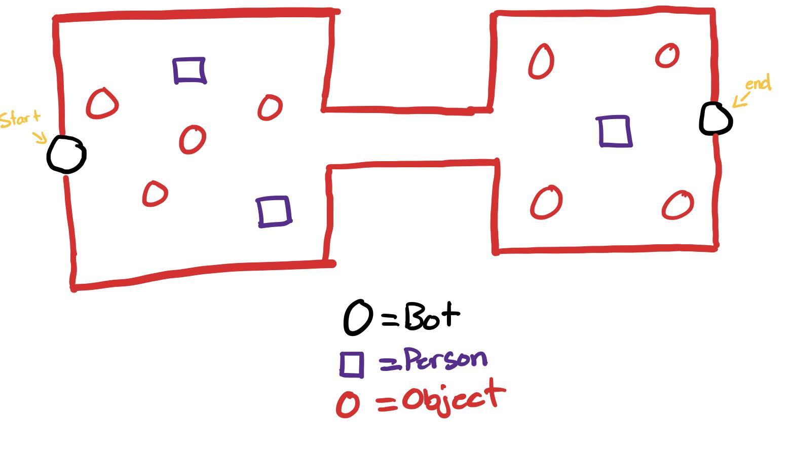
Final Field:
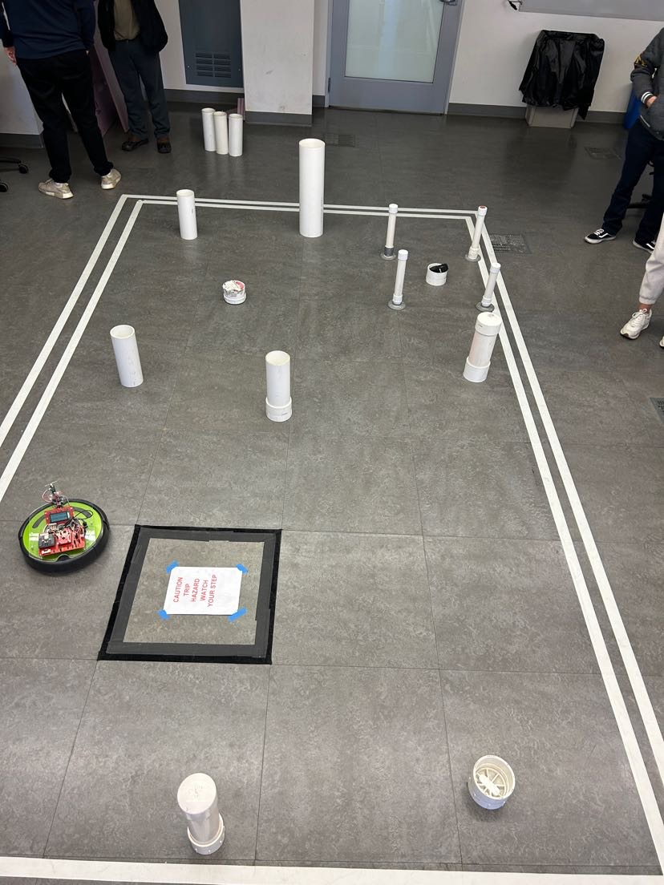

Prototype: Our Rescue Bot is designed for cave exploration and is equipped with advanced sensor technology and
artificial intelligence capabilities that enable it to effectively scan for objects and people within the challenging and
often treacherous cave environments.
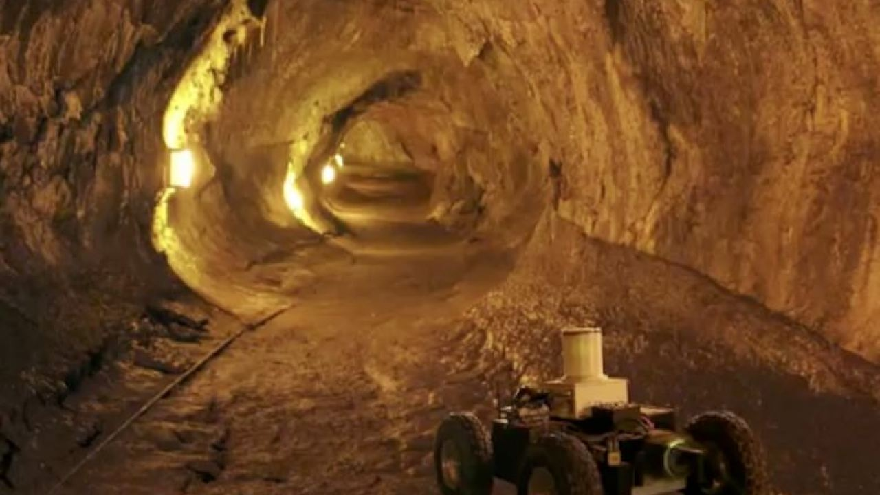

Contribution:
- Tristan - Problem Statement & Application Narrative
- Eli - Empathy Map: Miners
- Chris: Empathy Map: Rescuers
- Joseph: Sketch & Prototype

Team Member | Contributions
Tristan | Worked with the problem statement and the application narrative also developed the Python GUI to interact with the robot.
Eli
Chris
Joseph | Worked with the test sketches and also worked on the prototype.

Works Cited:

[1] C. Graham, "Chilean miners World exclusive interview with Mario Sepulveda," Daily Mail. [Online]. Available: https://www.dailymail.co.uk/news/article-1321230/Chilean-miners-World-exclusive-interview-Mario-Sepulveda.html. Accessed: Oct. 31, 2023.

[2] Carnegie Mellon University, "Autonomous Robots Map and Detect Objects in Mine," 2019. [Video]. Available: https://www.youtube.com/watch?v=uBUElSNNAIk. Accessed: Oct. 31, 2023.

[3] A. Chakravorty, "Underground Robots: How Robotics Is Changing the Mining Industry," Eos.org, May 13, 2019. [Online]. Available: https://eos.org/features/underground-robots-how-robotics-is-changing-the-mining-industry. Accessed: Oct. 15, 2023.

[4] G. Noone, "What does the future hold for automation in the mining industry?" NS Energy, Mar. 27, 2020. [Online]. Available: https://www.nsenergybusiness.com/features/automation-mining-industry-future/. Accessed: Oct. 15, 2023.

